GitHub Login
  - Login to Github and create Repo.
  - Git --version
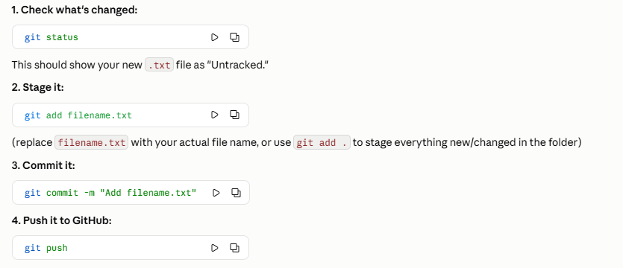
  - Create Dev branch
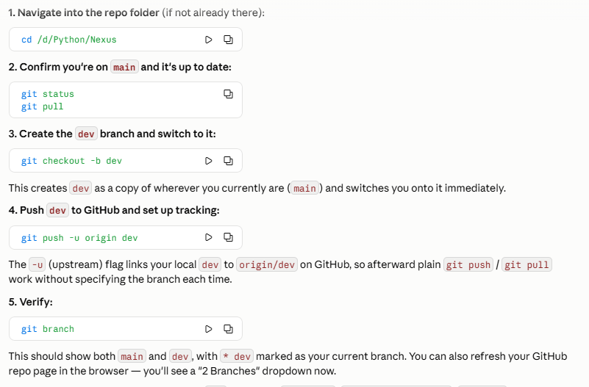

Open AI Key

